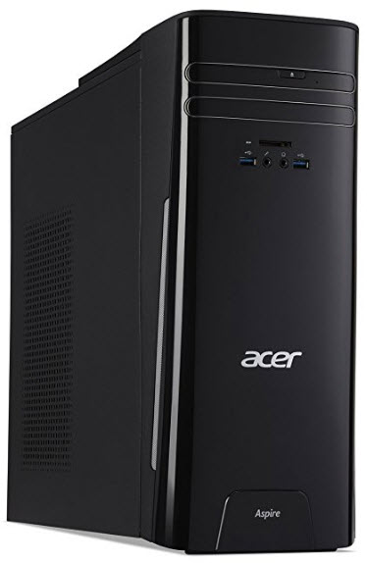
This unit does NOT come with a monitor. Add a monitor:

20” LCD Monitor $129
24” LCD Monitor $159
*ask for pricing over 24”
All Acer desktops come with a USB keyboard and mouse. You can substitute a wireless keyboard and mouse set for an additional $29

Acer Aspire TC780 Mid Tower $899
Intel Quad-Core i7 3.6 GHz CPU
8 GB DDR4 RAM (32 GB maximum capacity with 2 slots)
1 TB Hard Drive
DVD-Writer
Gigabit Ethernet, Wireless LAN, Bluetooth
Windows 10 Home 64-bit, Office 2016, CCleaner, Malwarebytes, Defraggler, Windows Defender
Wired Keyboard & Mouse
3 USB 3.0 Ports, 4 USB 2.0 Ports
1 HDMI Port, 1 VGA Port
Integrated Intel HD Graphics 630
SD Card Reader
6.9” Wide x 15.7” High x 17.43” Deep

