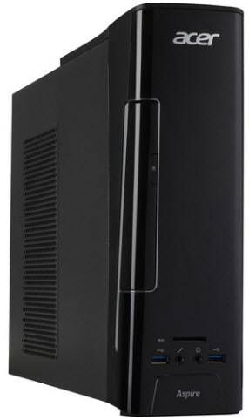
This unit does NOT come with a monitor. Add a monitor:

20” LCD Monitor $129
24” LCD Monitor $159
*ask for pricing over 24”

All Acer desktops come with a USB keyboard and mouse. You can substitute a wireless keyboard and mouse set for an additional $29

Acer Aspire AXC780 Mini Tower $599
Intel Dual-Core i3 3.9 GHz CPU
4 GB DDR4 RAM (32 GB maximum capacity with 2 slots)
1 TB Hard Drive
DVD-Writer
Gigabit Ethernet, Wireless LAN, Bluetooth
Windows 10 Home 64-bit, Office 2016, CCleaner, Malwarebytes, Defraggler, Windows Defender
Wired Keyboard & Mouse
3 USB 3.0 Ports, 4 USB 2.0 Ports
2 HDMI Ports
Integrated Intel HD Graphics 630
SD Card Reader
3.9” Wide x 11.5” High x 29.2” Deep

